PROJECT DOCUMENTATION

Laptop Request Catalog Item

ServiceNow

PREPARED BY: DANTULURI NANDINI

DATE: 16/09/2025

1.INTRODUCTION:
Project Overview
Organizations often face challenges in handling IT hardware requests especially laptops due to outdated, manual processes. These traditional methods result in inefficiency, delays, poor communication, and lack of visibility.
This project introduces an automated Laptop Request process in ServiceNow through the Service Catalog. It leverages dynamic input fields, reset options, conditional visibility rules, and update set management to ensure smooth migration across instances.
Purpose
The purpose of this project is to replace manual workflows with a streamlined digital solution. Using ServiceNow capabilities, the solution enables:
- Faster request handling
- Standardized information capture
- Improved user experience
- Easier migration between environments through update sets
The system addresses key pain points for both employees and IT support teams while allowing flexibility for future enhancements.

2. IDEATION PHASE
Problem Statement
Currently, laptop requests are raised informally (emails/verbal communication), causing process gaps. This leads to:
- Incomplete or incorrect submissions
- Poor tracking and visibility
- Increased IT workload
- Delays and employee frustration
The proposed solution: a centralized catalog item in ServiceNow.

Empathy Map
Who? Regular employees requesting laptops
- Think & Feel: Frustrated with unclear, lengthy processes
- See: Unstructured communication and lack of request visibility
- Say & Do: Repeatedly follow up with IT staff for updates
- Hear: Complaints from colleagues about delays
- Pain: Miscommunication, inefficiency, missed deadlines
- Gain: Transparent, simple, and efficient request experience

3. REQUIREMENT ANALYSIS
Customer Journey
- User logs into ServiceNow
- Navigates to Service Catalog → Laptop Request
- Dynamic form adapts based on inputs (model, accessories, etc.)
- Request submitted → routed to IT processing
- Transparent and guided experience for employees
Solution Requirements
- Single catalog item for laptop requests
- Fields: laptop model, business justification, accessories
- Conditional visibility for accessory details
- Reset button to clear inputs
- Update set export/import for portability
- Compatibility across ServiceNow instances
FLOW:
User → Service Catalog → Laptop Request Form → UI Policies → Submission
↓
Update Set
↓
Export/Import XML → Target Instance
Technology Stack
- Platform: ServiceNow (Orlando or later)
- Languages: JavaScript (GlideForm APIs), XML
- Modules: Service Catalog, UI Policies, UI Actions, Update Sets
- Testing: Manual verification in target environment
4. PROJECT DESIGN
Problem-Solution Fit
The solution enforces complete submissions, reduces IT rework, and ensures data quality through conditional UI rules.
Proposed Solution
Laptop Request Catalog Item in the Hardware category:
- Dynamic fields (model, justification, accessories)
- UI policies for conditional visibility & mandatory rules
- Reset functionality (UI Action)
- Update set portability
Solution Architecture
- Frontend: Dynamic Service Catalog form
- Logic Layer: UI Policies & Actions (JavaScript)
- Persistence Layer: ServiceNow tables
- Deployment: Update sets (XML export/import)
5. PROJECT PLANNING & SCHEDULING
Execution Steps
- Create Update Set → Capture all changes
- Build Catalog Item → Laptop Request entry
- Add Variables → Capture input fields
- Configure UI Policies → Conditional logic
- Add Reset Button → Usability
- Test in Dev → Validate functionality
- Export/Import → Deploy to new instance
6. IMPLEMENTATION WORKFLOW
- Create Local Update Set
- Navigate: All → Update Sets → Local Update Sets
- Create & make current
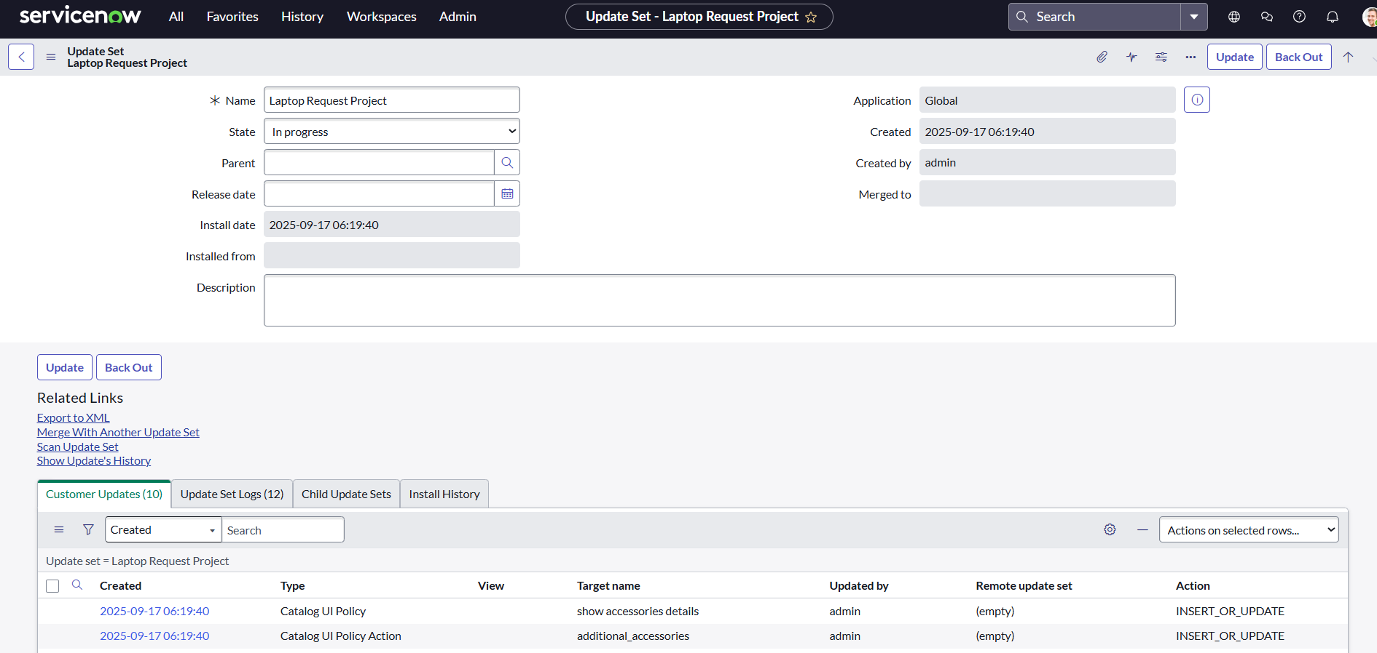
- Create Catalog Item
- Navigate: All → Service Catalog → Maintain Items
- Add item: Laptop Request (Hardware category)
- Click on New.
- Fill the following details to create a new catalog item
Name: Laptop Request
Catalog: service Catalog
Category: Hardware
Short Description: Use this item to request a new laptop
- Click on ‘SAVE’
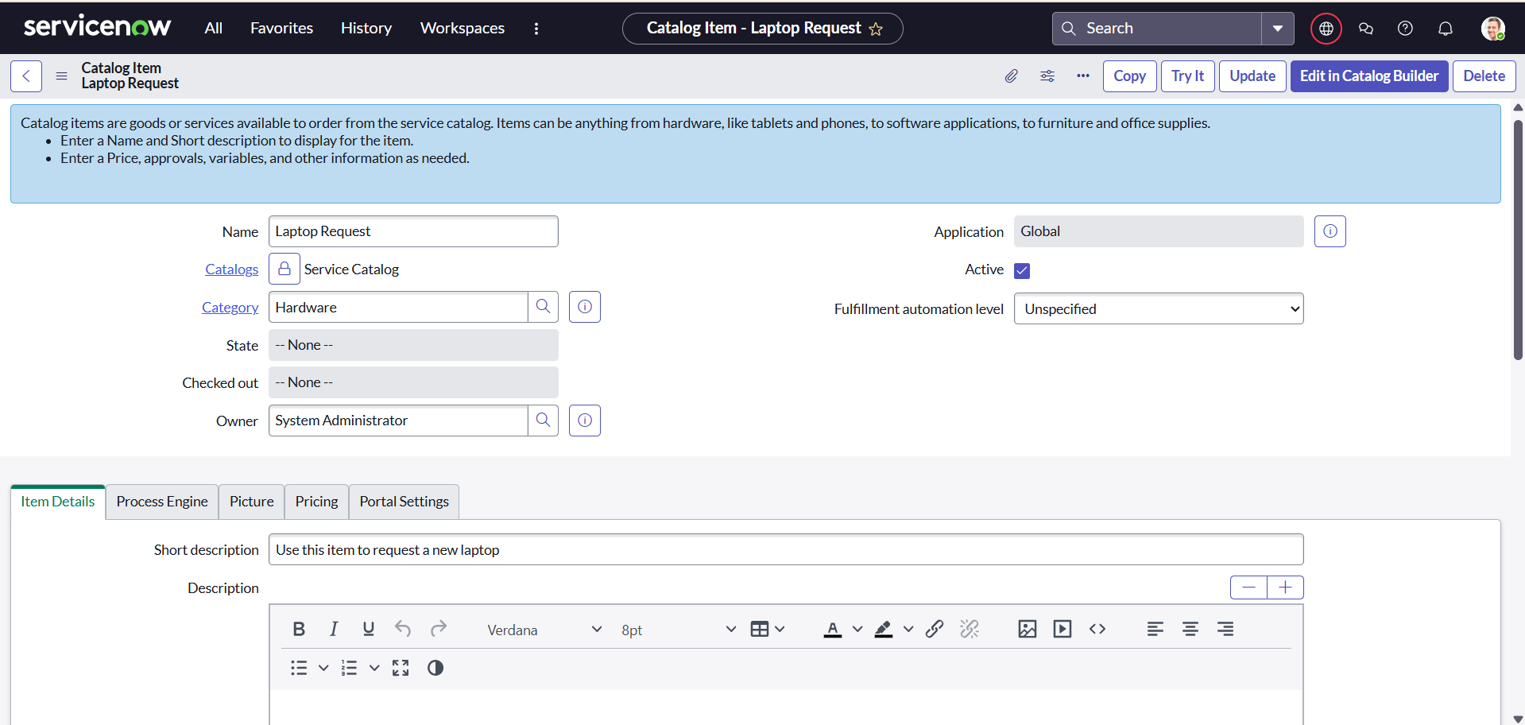
- Add Variables
- Fields: Laptop model, justification, accessories
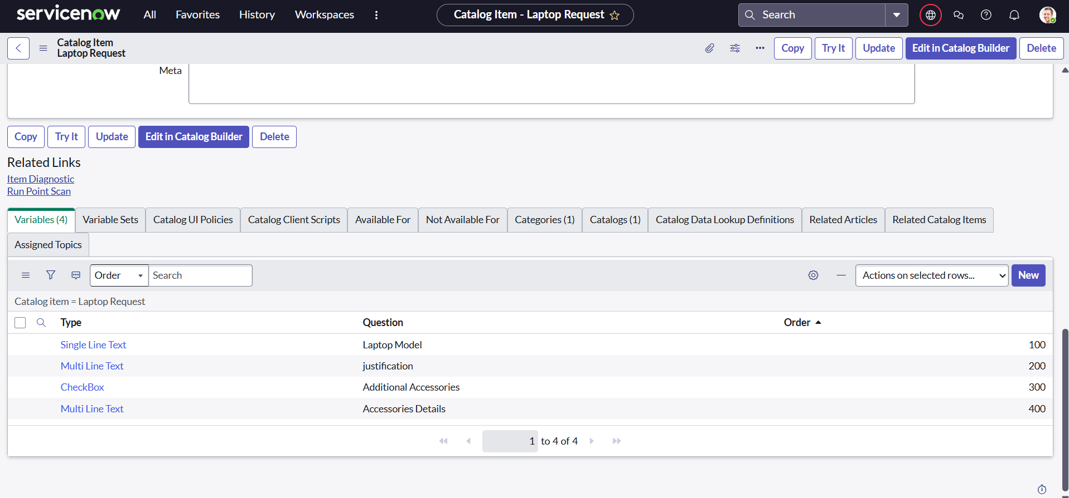

- UI Policy
- Show "Accessory Details" only when "Additional Accessories" is selected
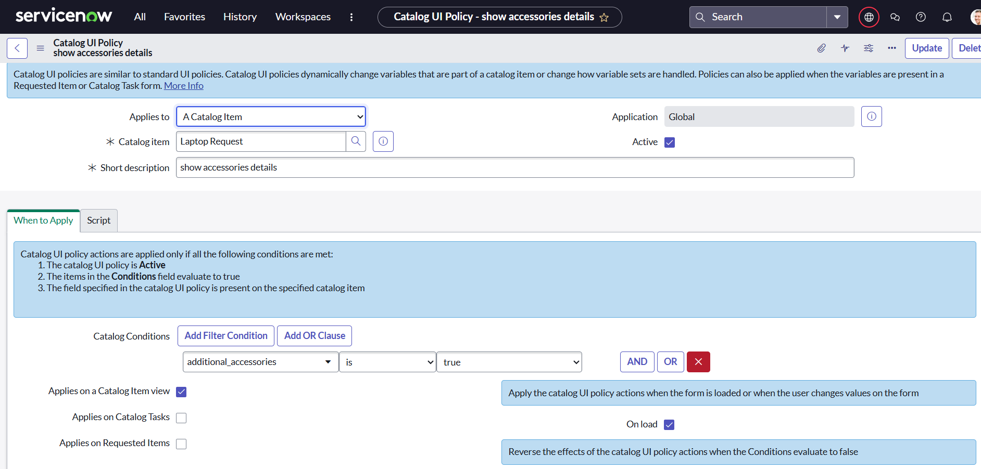
- UI Policy Action
- Make "Accessory Details" visible & mandatory
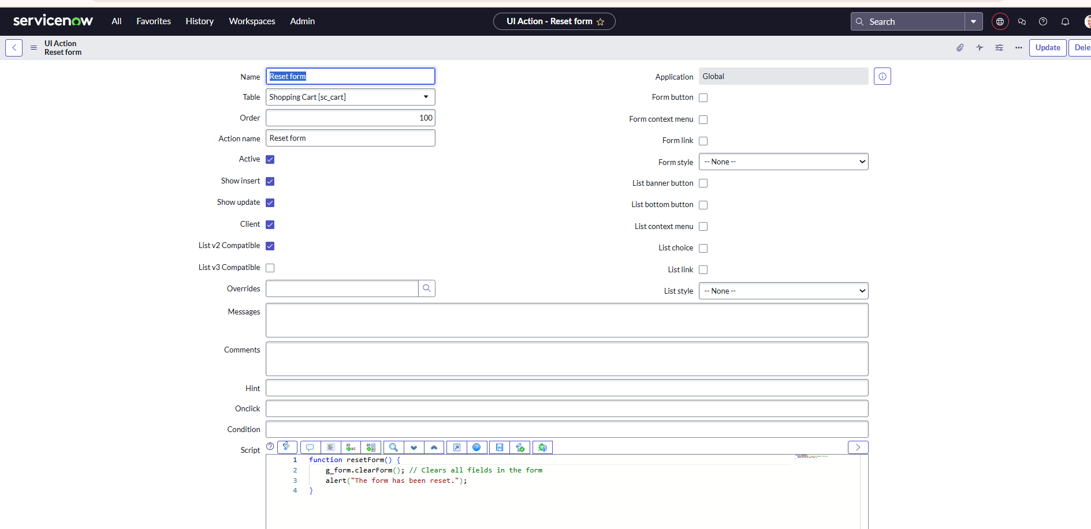

- UI Action (Reset Button)
function resetForm() {
g_form.clearForm();
alert("Form has been cleared.");
}

- Export & Import Update Set
- Export from Dev → XML
- Import into Target Instance → Preview → Commit
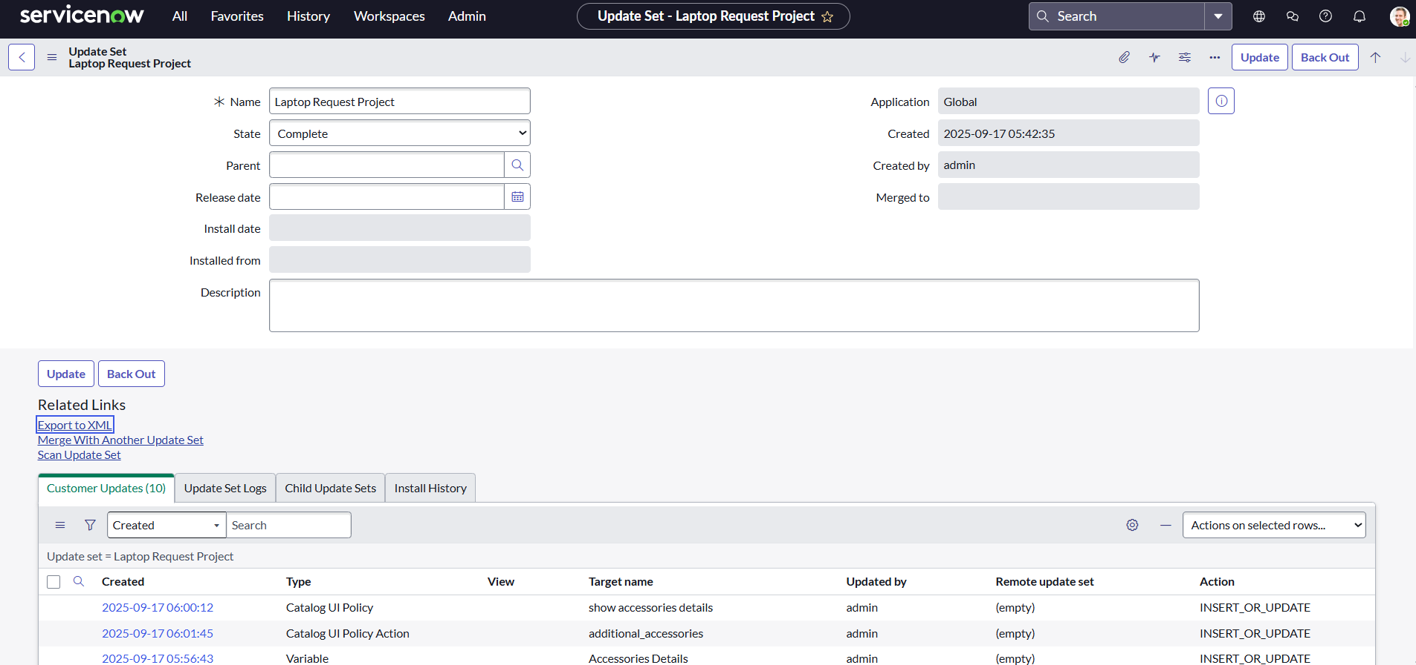

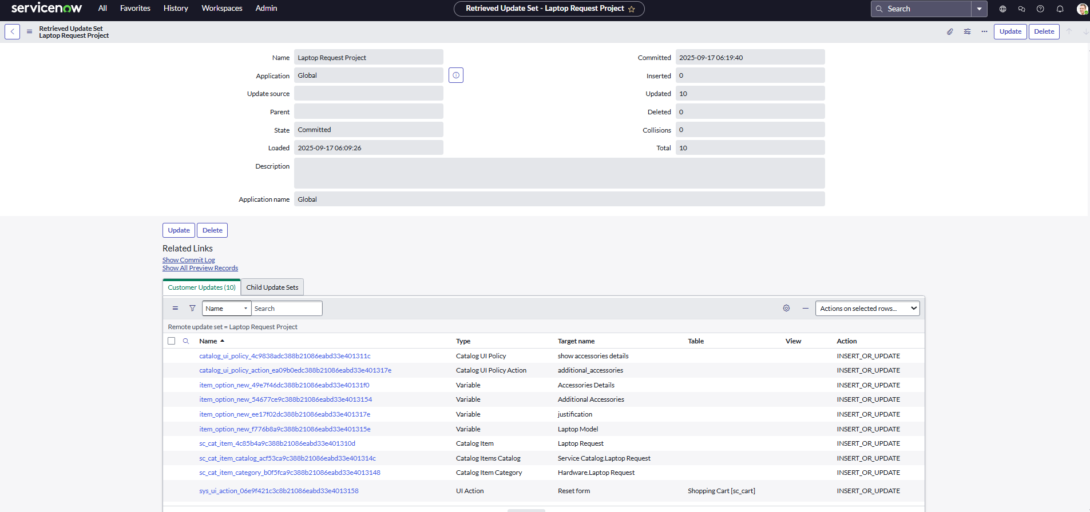

7. FUNCTIONAL & PERFORMANCE TESTING
- Confirm default fields visibility
- Accessory details appear only when selected
- Reset button clears inputs successfully
- Mandatory validation prevents incomplete requests
- Tested across multiple scenarios

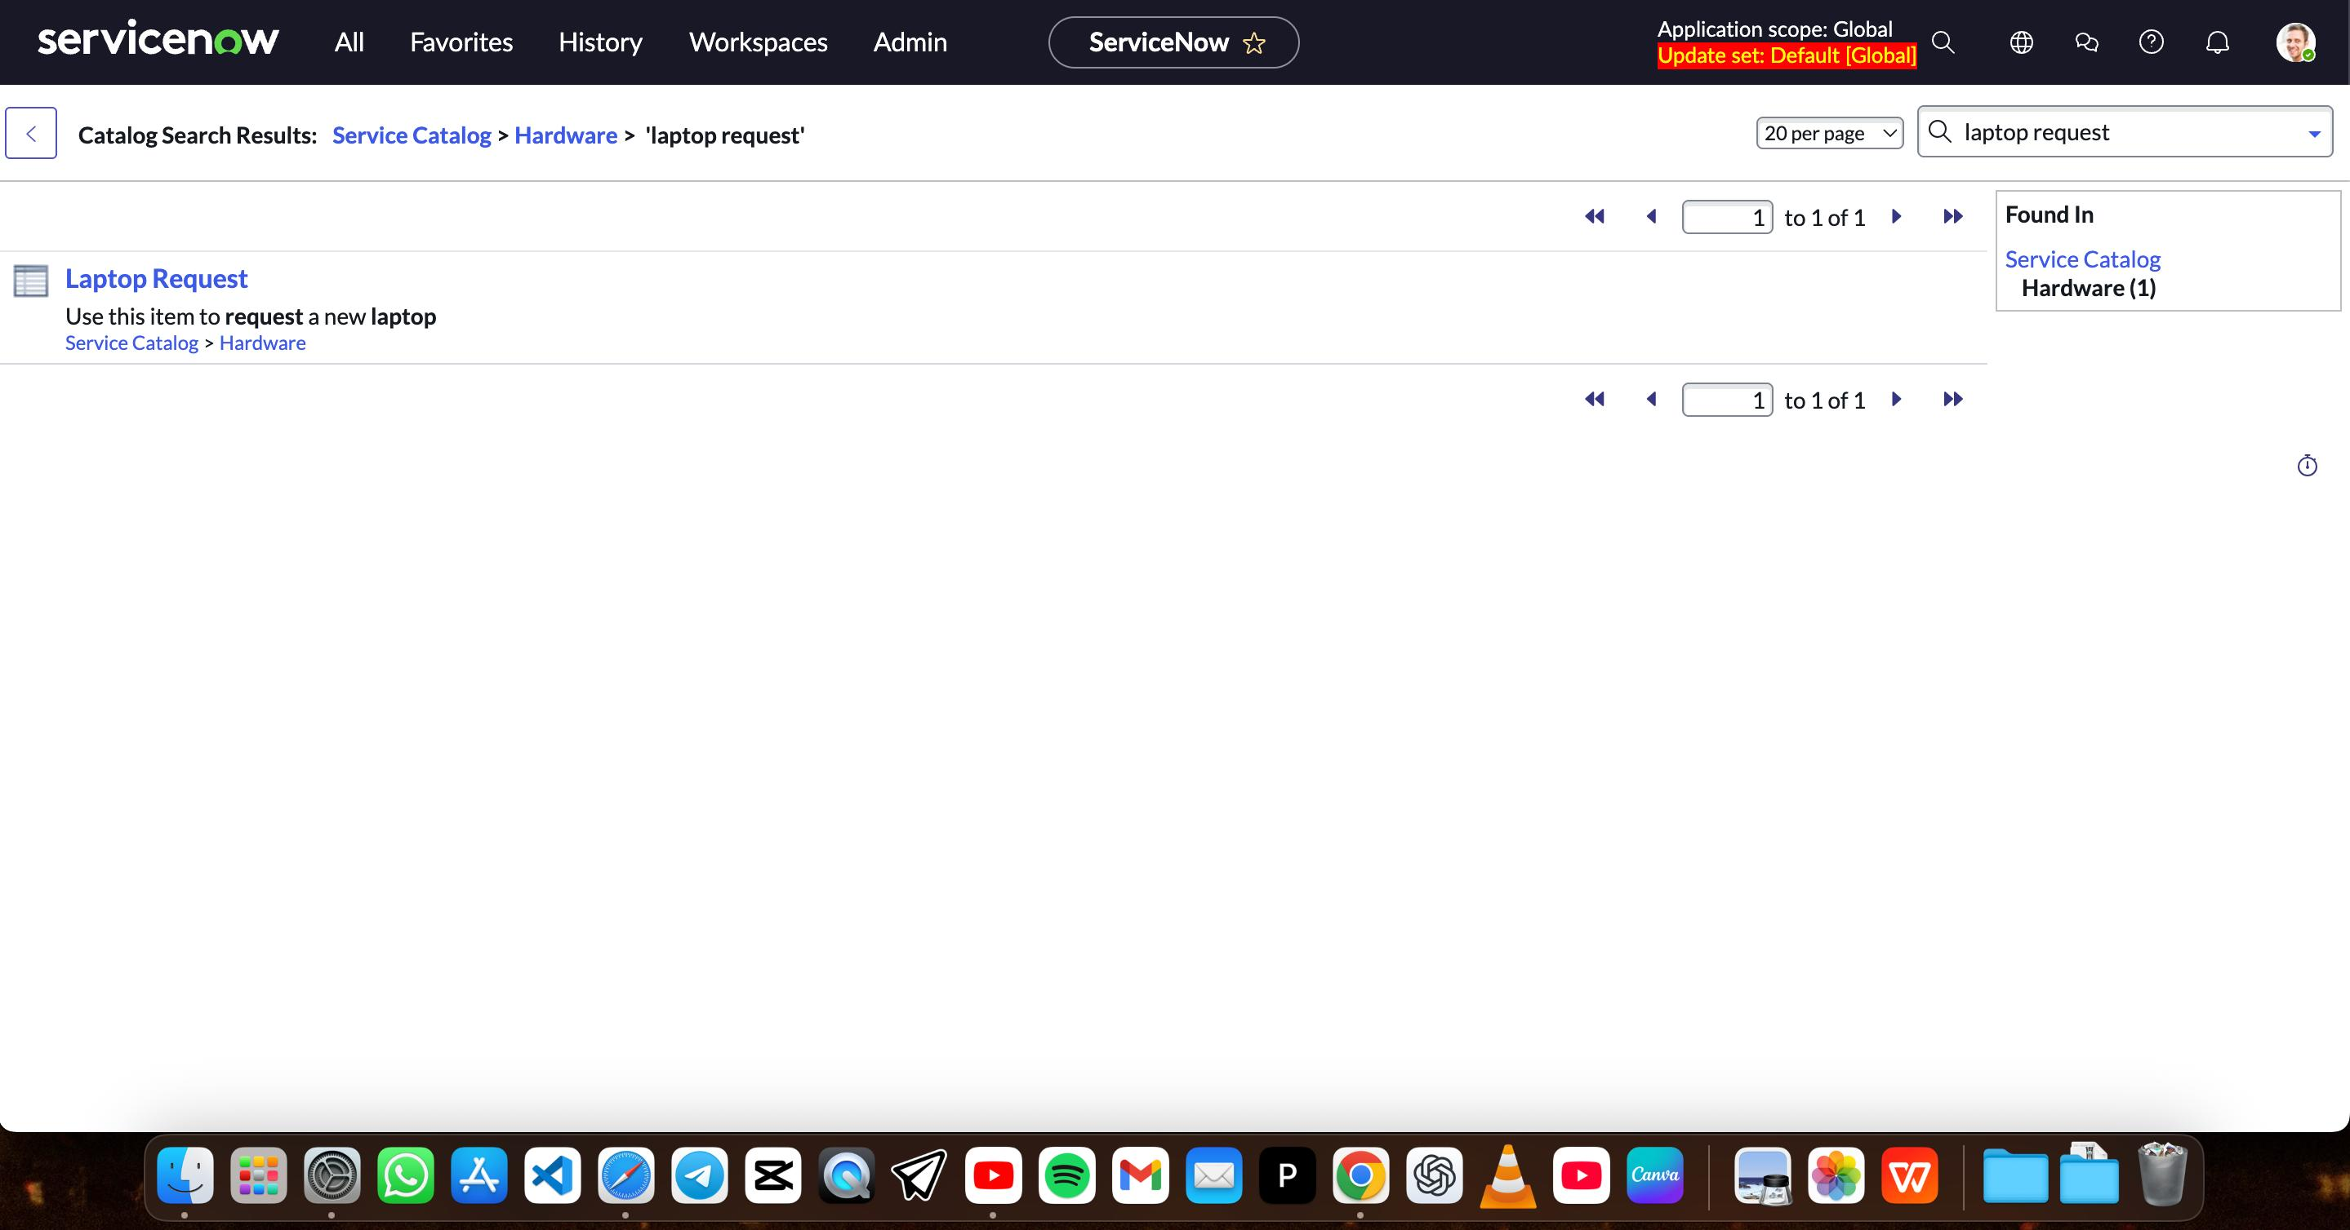

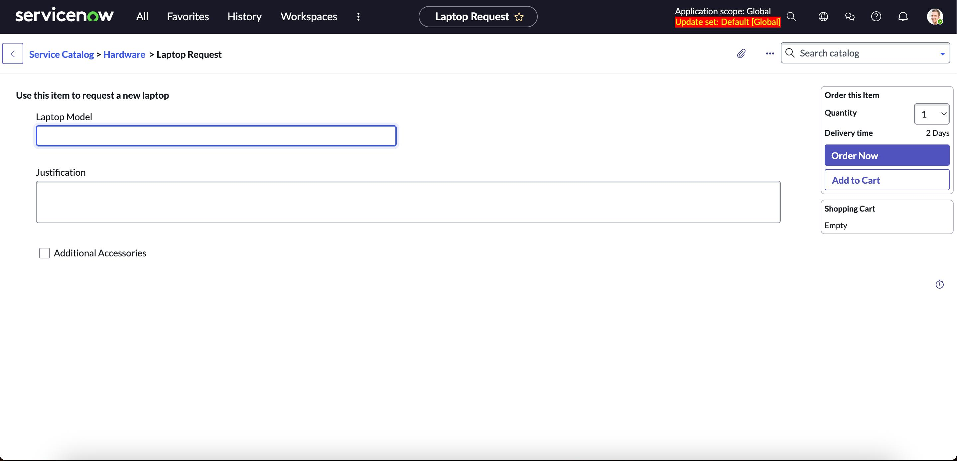

8.CONCLUSION
The Laptop Request Catalog Item provides a structured, user-friendly way to request laptops in ServiceNow. It eliminates inefficiencies, ensures accurate data capture, and enhances both IT operations and employee satisfaction.

